## **Linux Task**

## **Name: Rakesh -15**

1. **Create user with name Techie and provide sudo access to user.**

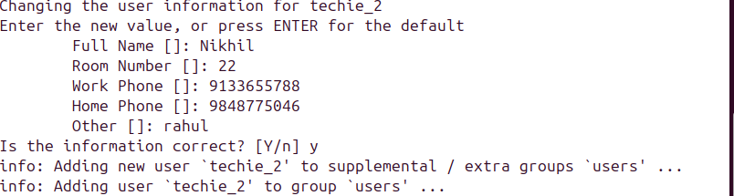

1. **Navigate to the home directory.**

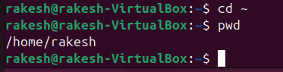

1. **Create a new directory**

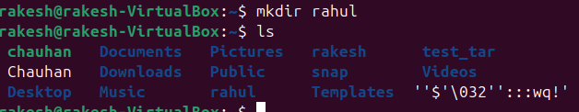

1. **List the contents of a directory.**

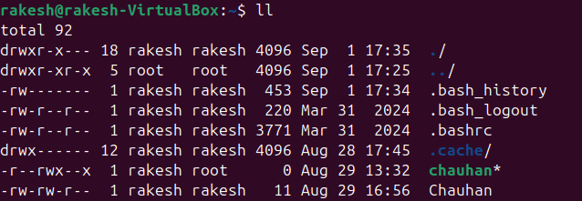

1. **Change the current directory**

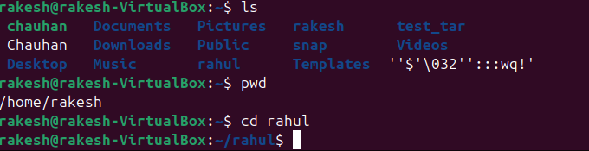

1. **Create a new empty file.**

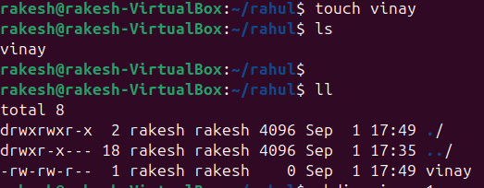

1. **View the contents of a file.**

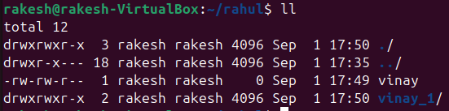

1. **Copy a file to another location.**

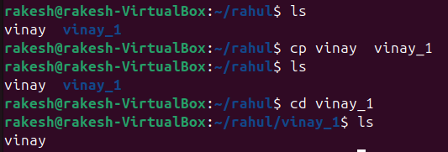

1. **Move a file to another location.**

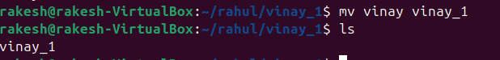

1. **Rename a file.**

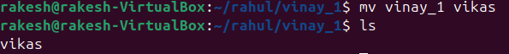

1. **Delete a file.**

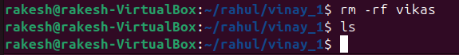

1. **Grant or revoke permissions on a file or directory.**

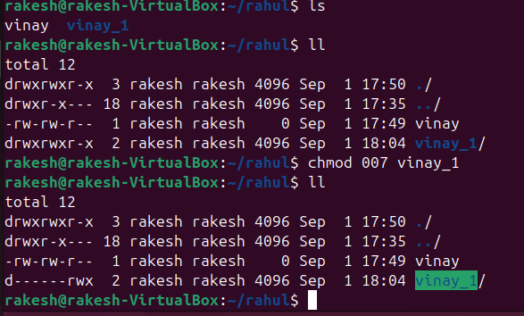

1. **View the current date and time.**

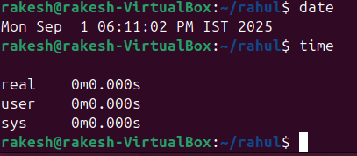

1. **Check the system uptime.**

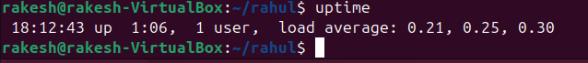

1. **View the running processes**

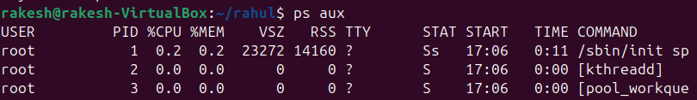

1. **Kill a running process.**



1. **Install a package using the package manager (e.g., apt or yum)**

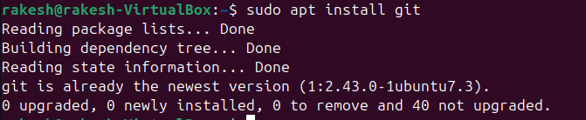

1. **Update the system packages**

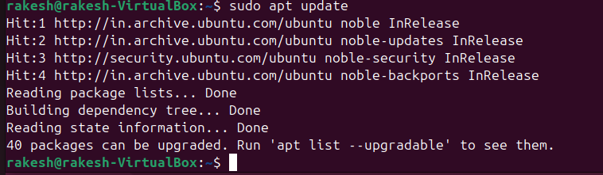

1. **Create a symbolic link**

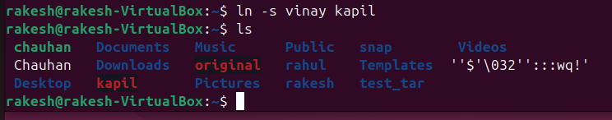

1. **Search for files using the find command.**

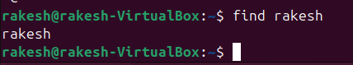

1. **Compress and decompress files using tar.**

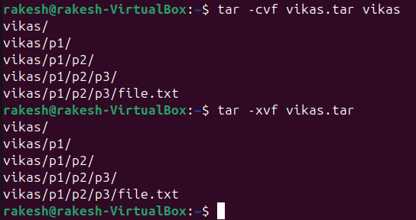

1. **Monitor system resources with top or htop**

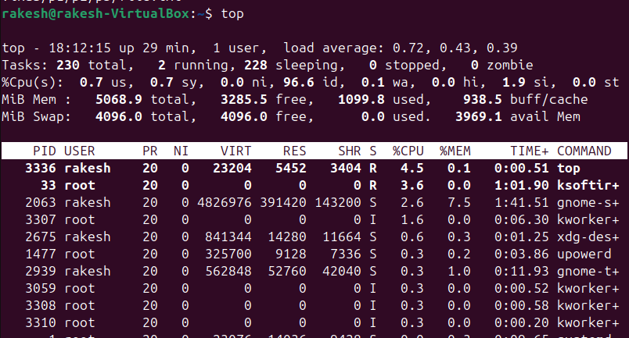

1. **Create and manage user groups.**

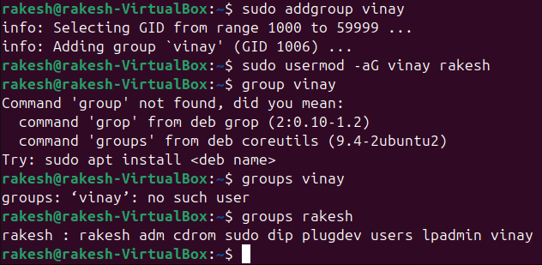

1. **Set up SSH password less authentication**

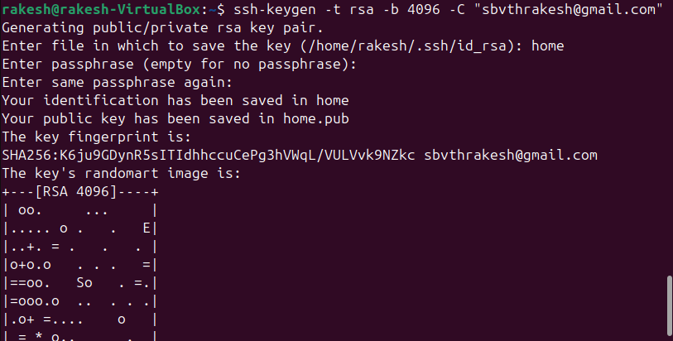

1. **Monitor log files using tail or grep**

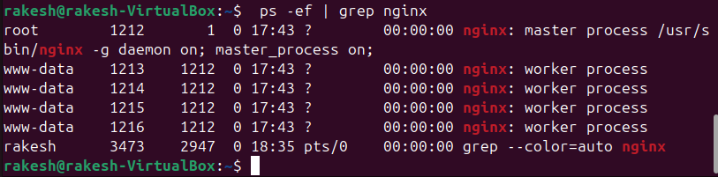

1. **Set up a web server (e.g., Apache or Nginx)**

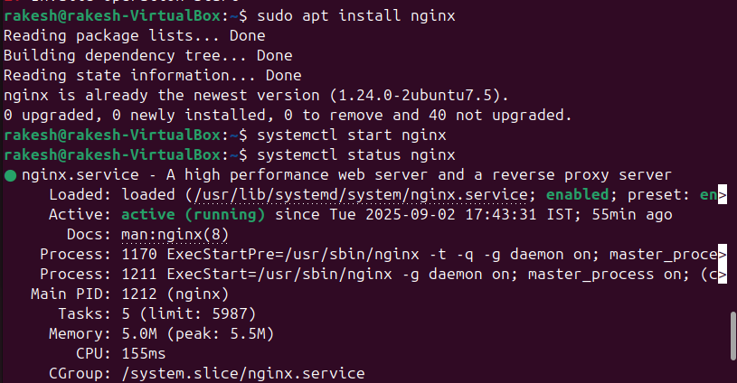

1. **Configure and secure a MySQL Database.**
2. **Set up a Application Server (e.g.,Apache Tomcat)**
3. **create a service file for Apache Tomcat.(Should execute by using systemtctl command)**
4. **Print specific columns from a delimited file**

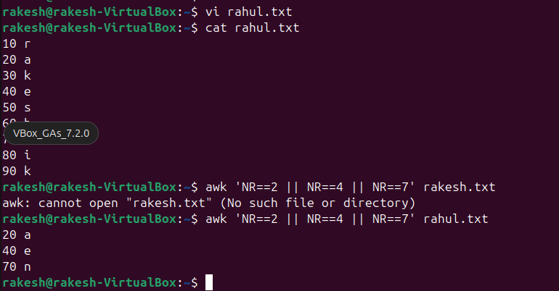

1. **Filter and print lines based on a specific pattern or condition**

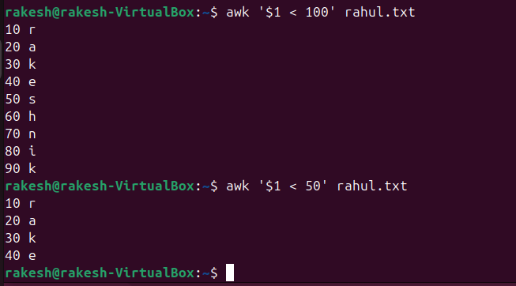

1. **Calculate and print the average, sum, or other statistics of a column**

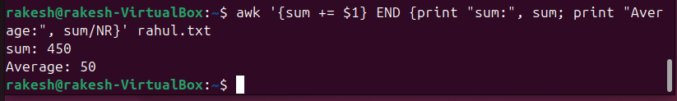

1. **Perform string manipulation, such as extracting substrings or changing case**

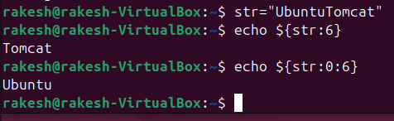

1. **Count the occurrences of a specific pattern in a file**

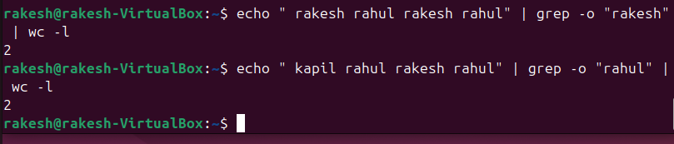

1. **Sort lines based on a specific field or column**

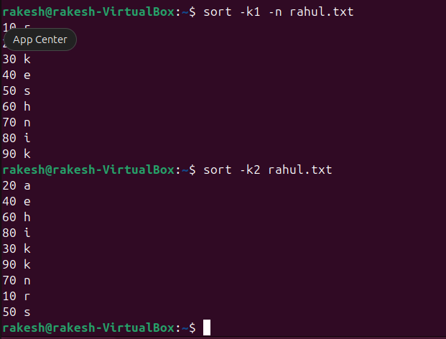

1. **Merge multiple files based on a common field or column.**

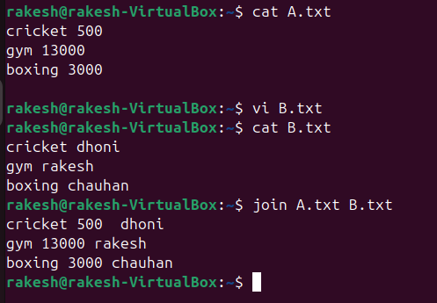

1. **Substitute text in a file using search and replace**

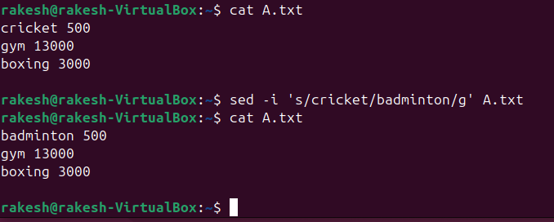

1. **Delete specific lines based on a pattern or line number.**

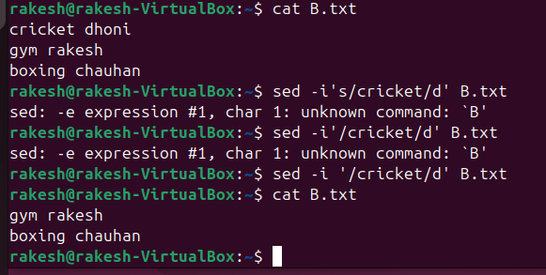

1. **Append or insert text before or after a specific pattern or line**

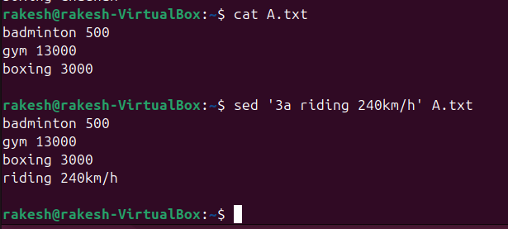

1. **Print only specific lines from a file**

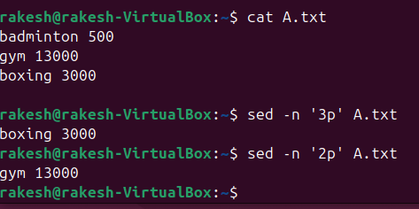

1. **Copy file from linux to windows machine**
2. **5 use cases for AWK and 5 use cases for sed**

